Monday | Tuesday | Wednesday | Thursday | Friday
 | 1  Read: The Ant and the Chrysalis  “Fox in Socks” | 2  “Green Eggs and Ham”  Happy Birthday Dr. Seuss!! | 3  “One Fish Two Fish”  Wear red & blue | 4  Dr. Seuss Day!  Dress as your favorite Dr. Seuss character
7  Fished the Alphabet yay!!!  Review A-Z  #19 | 8  Group project  Paint a rainbow | 9  Color mixing fun  Finish group project | 10  Scissor practice  shapes | 11  Scissor practice  Finish shapes
14  Last number #20  Easel Paint a shamrock  Leprechaun Traps are due | 15  Make a Leprechaun  *Start sight words | 16  Pot of gold craft | 17  St Patrick’s Day!  Wear green | 18  Go on a nature walk & visit the butterfly garden
21  It’s SPRING!  Talk about the change in seasons | 22  Flower art project  Tearing paper art | 23  Spring tree  Painting project | 24  Crayon resist flower art | 25  Cloud shapes  Sensory bin
28  B-I-N-G-O | 29  Kaboom Game | 30  ABC exercise | 31  Free Play  Sensory bin | 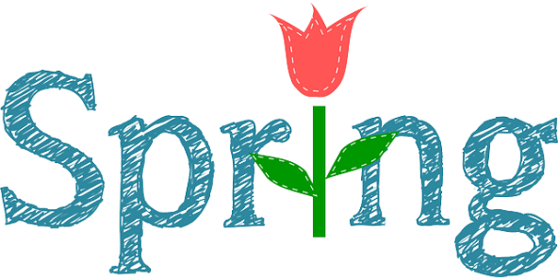
Room 11 Mrs. Brook

