|  |  |  |  |  |
| --- | --- | --- | --- | --- |
| Monday | Tuesday | Wednesday | Thursday | Friday |
| 31  HALLOWEEN PARTY | 1  Letter Ll  Number 6  Observing the weather | 2  Letter “Ll” collage | 3  Seasons of the Year | 4  Find the “Ll” sound  ***Addison’s B-Day 11/6*** |
| 7  Letter Rr  Number 7  The Four Seasons | 8  Story time:  The Reasons for Seasons, by Gail Gibbons | 9  Four Seasons Matching Worksheet  ***Ms.Bianca’s B-Day*** | 10  Seasons and Clothing | 11  CRAFT  Seasonal Tree |
| 14  Letter Cc  Number 8  Outer Space | 15  Galaxy Dough | 16  Space Sensory Bin | 17  Space Wreaths | 18  Story Time:  Solar System, by Jill McDonald |
| 21  Thanksgiving Craft | 22  Thanksgiving Craft | 23  Thanksgiving Craft | 24  CENTER CLOSED | 25  CENTER CLOSED |
| 28  Letter Ee  Number 9  Pets | 29  Our Favorite Pet Graph | 30  Story Time:  What Pet Should I get?, by Dr.Seuss | 1  What Pet would I choose? | 2  Fur or Feathers? |

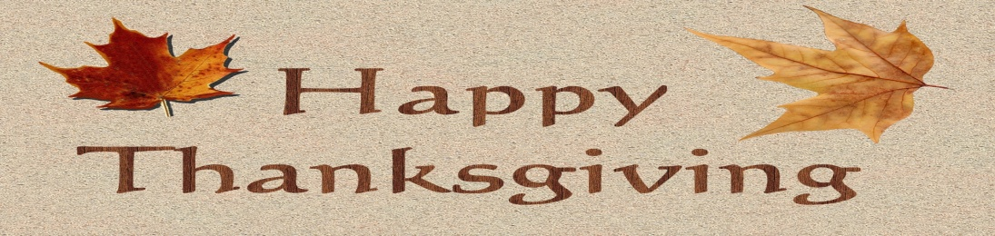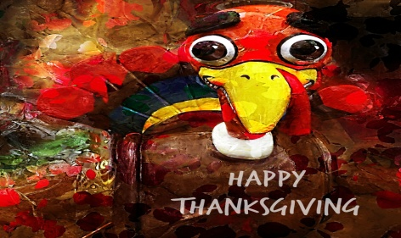C:\Program Files (x86)\Microsoft Office\MEDIA\CAGCAT10\j0212661.wmf