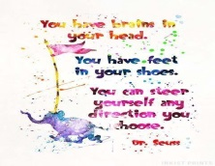March 2022
Notes and Themes | Monday | Tuesday | Wednesday | Thursday | Friday
Month Themes:  - Dr. Suess  -Saint Patty’s Day | 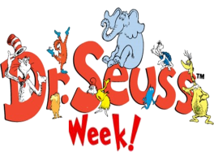 | 1 Crazy Sock Day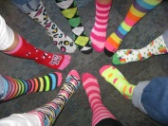 | 2 Wear Green  *********** | 3 Wear red/blue  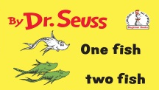 | 4 Dress up as your favorite Dr.Seuss Character | **********  We will be having Green Eggs and ham for AM snack on 3/2
Letters of the Month:  Ll, Ff, Bb | 7 “Ll” tracing and Leprechaun Hat | 8 #11 tracing  and Dr. Seuss hat craft | 9 Walking Rainbow Science Project | 10 Clover marble painting | 11 Paper Plate Rainbow
Numbers of the Month:  12,13,14 | 14 “Ff” tracing and finger painting | 15 #12 tracing and a Shape Recognition Worksheet | 16 “Oh the places you’ll go” craft | 17 St. Patty’s Day  **** Party **** | 18 Pajama Day & Leprechaun Trail Mix
Book of the Month:  Variety of  Dr. Seuss Books | 21 “Bb” tracing and Bubble painting | 22 #13 tracing and Lucky Graph | 23 Rainbow Heart Name making | 24 Foot Loop Rainbow Necklace | 25 “It looked like spilt milk” story and craft
 | 28 ABC and Number Review | 29 Seed in a bag project | 30 Get ready for Spring

