Monday | Tuesday | Wednesday | Thursday | Friday
1  Story Time:  Froggy goes to Hawaii  By: Jonathan London | 2  Arts & Crafts:  Thumb prints Pineapples | 3  Math:  Match the number to the correct picture. | 4  Sensory:  Kinetic Sand | 5  SPORTS DAY!
8  Language:  Rhyming words | 9  Story Time:  Hula Lullaby  By: Erin Kono | 10  Arts & Crafts:  Making Tiki Masks | 11  Math:  Practicing Addition | 12  DISNEY DAY!
15  Arts & Crafts:  Hibiscus Flower | 16  Math:  Practicing Subtraction | 17  Story Time:  Slippers in Hawaii  By: Jamie Kimel | 18  Sensory:  Shells and Sand | 19  WESTERN DAY!
22  Sensory:  Water Beads | 23  Arts & Crafts:  Hand Prints Palm Trees | 24  Language:  Hawaiian Words | 25  Story Time:  Leilani’s Luau  By: Sheila Sweeny | 26  END OF SUMMER LUAU AND ICE CREAM PARTY!
29  Arts & Crafts:  Hawaiian Shirts  Introduction to the class and rules | 31  Sensory:  Shaving Cream  Introduction to the class and rules | 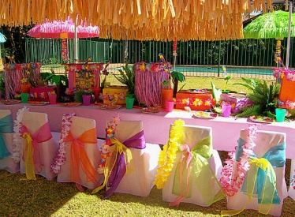 | 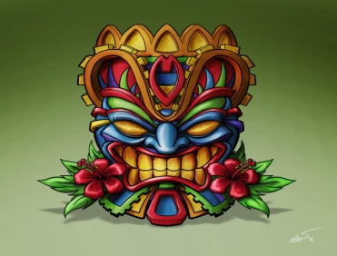 | 