**March Newsletter**

Room #5- Ms. Claudia

**Theme:**

* **Spring**



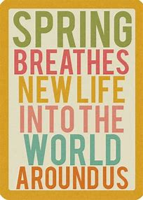

**This Month:**

* **Color: Green**
* **Letter: C**
* **Number: 3**
* **Shape: Triangle**

**Featured Book:**

