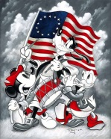 July 2022 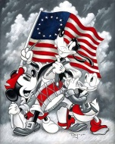
Notes and Themes | Monday | Tuesday | Wednesday | Thursday | Friday
Month Themes:  -4th of July  - Under the Sea |  |  |  |  | 1 Patriotic Snack  (Patriotic Dress Up Day! 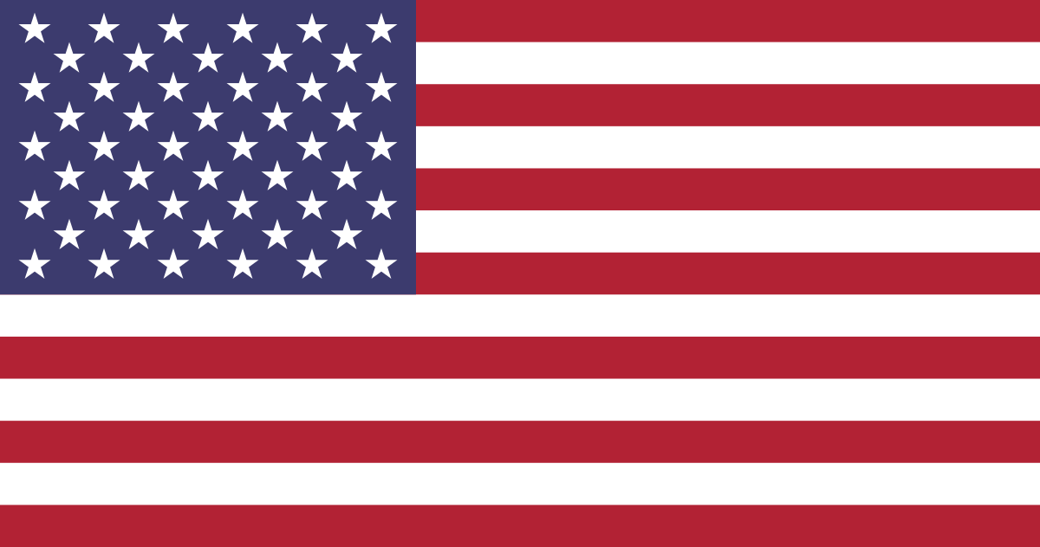)
Letters of the Month:  ABC review | 4 Center Closed | 5 Fork Firework Art | 6 Handprint American Flag | 7 Mint Firework Science Project | 8 Uncle Sam Hat Craft
Numbers of the Month:  Review 1-20 | 11 Paper Plate Shark | 12 Handprint Beach craft | 13 Counting Octopus | 14 Scrap Book Sea Turtle | 15 Shark Sun Catcher
Book of the Month:  Rainbow Fish | 18 Corral Reef Sponge Painting | 19 Crab  Handprint Art | 20 Puffer Fish Art | 21 Ocean Doyle Crowns | 22 Sting Ray Paper Plate craft
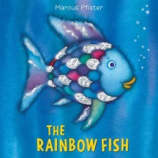 | 25 Rainbow Fish Art | 26 Ocean Silhouette painting | 27 Chalk Jellyfish | 28 Painting Sea Shells | 29 Friendship Fruit Salad (International Friendship Day 6/30) | 