Week 1
Monday | Tuesday | Wednesday | Thursday | Friday
Peanut butter & Graham Crackers  Chicken Burrito Bowls Over Rice w/  Black Bean & Corn  Shredded Cheese  Sour Cream  Cheez it’s & Fruit | Apple Slices & Yogurt  Cheeseburger Mac w/ Ground Beef  Salad w/ Ranch  Pears  Goldfish & Fruit | Orange Slices & Ritz Crackers  Cheese Quesadilla  Country Potatoes Mixed Fruit  Chips & Humus | Cheerios & Milk  Chicken Nuggets Mixed Vegetable  Apples  String Cheese & Crackers | Oatmeal & Fruit  Chicken Alfredo Noodles  Green Beans  Pineapple  Chewy Granola Bars & Fruit

Week 2
Monday | Tuesday | Wednesday | Thursday | Friday
Cottage Cheese & Fruit  Chicken Cheddar Broccoli Soup  Dinner Roll  Peaches  Turkey & Cheese with Crackers | Animal Cookies & Milk  Meatballs Subs w/ Cheese  Vegetable Blend  Pineapple  Fruit & Crackers | Applesauce & Graham Crackers  Mini Corn Dogs  Mixed Vegetables  Apple Slices  Bean Dip & Chips | Vanilla Wafers & Yogurt  Spaghetti w/ ground beef  Sweet Corn  Pears  Peanut Butter & Ritz Crackers | Bagel w/ Cream Cheese & Raisins  Turkey & Cheese Sandwiches  Crispy Green Beans  Orange Slices  Veggies & Ranch Dip

Week 3
Monday | Tuesday | Wednesday | Thursday | Friday
Graham Crackers & Milk  Cheddar Mac & Cheese  Green Beans  Peaches  Veggies & Ranch | Cheerios & Milk  Peanut butter & Jelly Sandwiches  Potato Chips  Mixed Fruit  Goldfish & Fruit | Orange Slices & Crackers  Turkey Hot Dog  Cucumbers  W/ Ranch  Apple slices  Chewy Granola Bars & Fruit | Apple Sauce & Graham Crackers  Chicken Pot Pie  w/ Mixed vegetables  Pineapple  Crackers w/ Cheese | Yogurt & Animals Cookies  Sweet & Sour Meatballs over Rice  Green Beans  Orange Slices  Peanut Butter & Ritz Crackers

Week 4
Monday | Tuesday | Wednesday | Thursday | Friday
Bagel w/ Cream Cheese & Raisins  Chicken Noodle Soup  Crackers  Apple Slices  Pretzel & Cheese Slices | Mandarin Oranges & Cottage Cheese  Chicken “Fried” Rice  With Vegetables & Scrambled Eggs  Mixed Fruit  Spinach Dip & Chips | Crackers & Cheese  Grilled Cheese Sandwiches  Carrots with Ranch  Peaches  Goldfish & Fruit | Peanut Butter & Graham Crackers  Bean & Cheese Burritos  Seasoned Rice  Fruit  Veggies & Ranch | Cheerios & Milk  Chicken Nuggets  Green Beans  Applesauce  Fruit & Crackers

Week 5 (Used for months with 5 weeks)
Monday | Tuesday | Wednesday | Thursday | Friday
Fresh Fruit & Wheat Thins  Minestrone Soup w/ mixed vegetables  Crackers  Peaches  Turkey & Cheese Slices with Crackers | Yogurt & Vanilla Wafers  Mini Cheese Pizza Salad with Ranch  Fruit  Cheez-it’s & Fresh Fruit | Muffins & Milk  Taco Bowls, Ground beef, Corn, Cheese, Fritos Chips  Pears  Veggies & Ranch Dip | Graham Crackers & Milk  Turkey Hot Dogs  Green Beans  Pineapple  String Cheese & Crackers | Apple Slices & Yogurt  Chili Con Carne & Cheese over rice  Mixed Vegetables  Apple Slices  Peanut Butter & Ritz Crackers
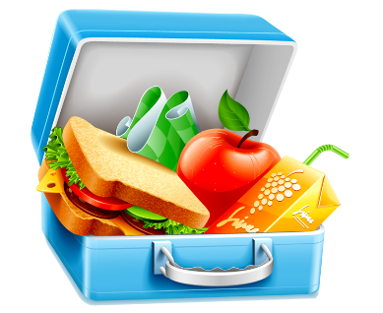
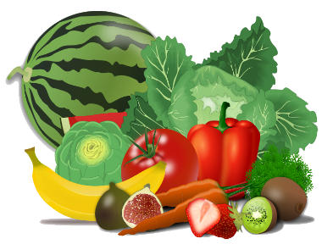
*Lunch is served with 1% Milk*
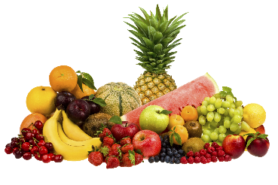
Nutritious Snacks are served in the morning & afternoon and include 2 food groups

