Monday | Tuesday | Wednesday | Thursday | Friday
28  Theme: Things Change  Letter Jj & Zz  Number: 19 | 1st  Letter Jj is for jellyfish  Talk about what things change | 2  Letter find worksheet  Number 18  Share day Jj & Zz | 3  Shape Builder worksheet  Letter Zz is for Zebra craft | 4  Book: The Ant and the chrysalis  Craft: Make butterfly and chrysalis
7  Alphabet Review  Theme: Look at us!  Number 20 | 8  Letter Sounds Worksheet | 9  Number 20 tracing | 10  Color the picture with letter sounds | 11  Movie Day
14  Make Leprechaun Hats | 15  Crepe-Paper Shamrock | 16  Bring in the party items!!!  Leprechaun Handprint craft | 17  St. Patrick’s Day Party  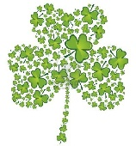 | 18  Leprechaun fork beard craft
21  Theme: Flowers | 22  Paper plate flowers | 23  Splatter Flower craft using toothbrush | 24  Bubble wrap flowers | 25  Tissue paper flower craft  Fun Friday
28  Theme: Rainbow | 29  Make rainbow sun craft | 30  Melted rainbow crayons project | 31  Rainbow Marble painting process art
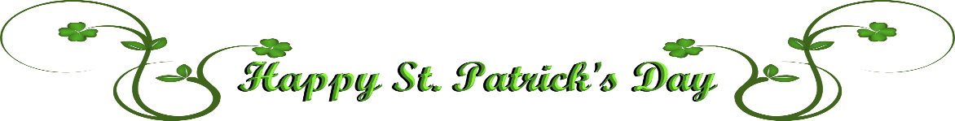
March

Miss.Ledya Room # 9

