Monday | Tuesday | Wednesday | Thursday | Friday
31st  Theme: Observation weather | 1  Letter Ll craft  Number 6 | 2  Who likes the rain? | 3  Paper plate rain cloud craft | 4  Cotton Swab rain cloud craft
7  Theme: The Four Season | 8  Letter Rr  Number 7 | 9  Make Cornucopia’s | 10  Fluffy Owls  Tracing Hearts | 11  Make a four season  booklet
14  Theme: Outer Space | 15  Letter Cc  Number 8 | 16  Name Rocket | 17  Outer Space Flying Saucer | 18  Make toilet paper  rocket
21  Theme: Thanksgiving craft | 22  Thanksgiving craft | 23  Talk about being Thankful | 24  Pepper Valley Closed  HAPPY THANKSGIVING | 25  Pepper Valley Closed
28  Theme: Pets | 29  Letter Ee  Number 9 | 30  The Frog Prince Book  Make frog craft | 1st  Crafts | 2  Review Shapes
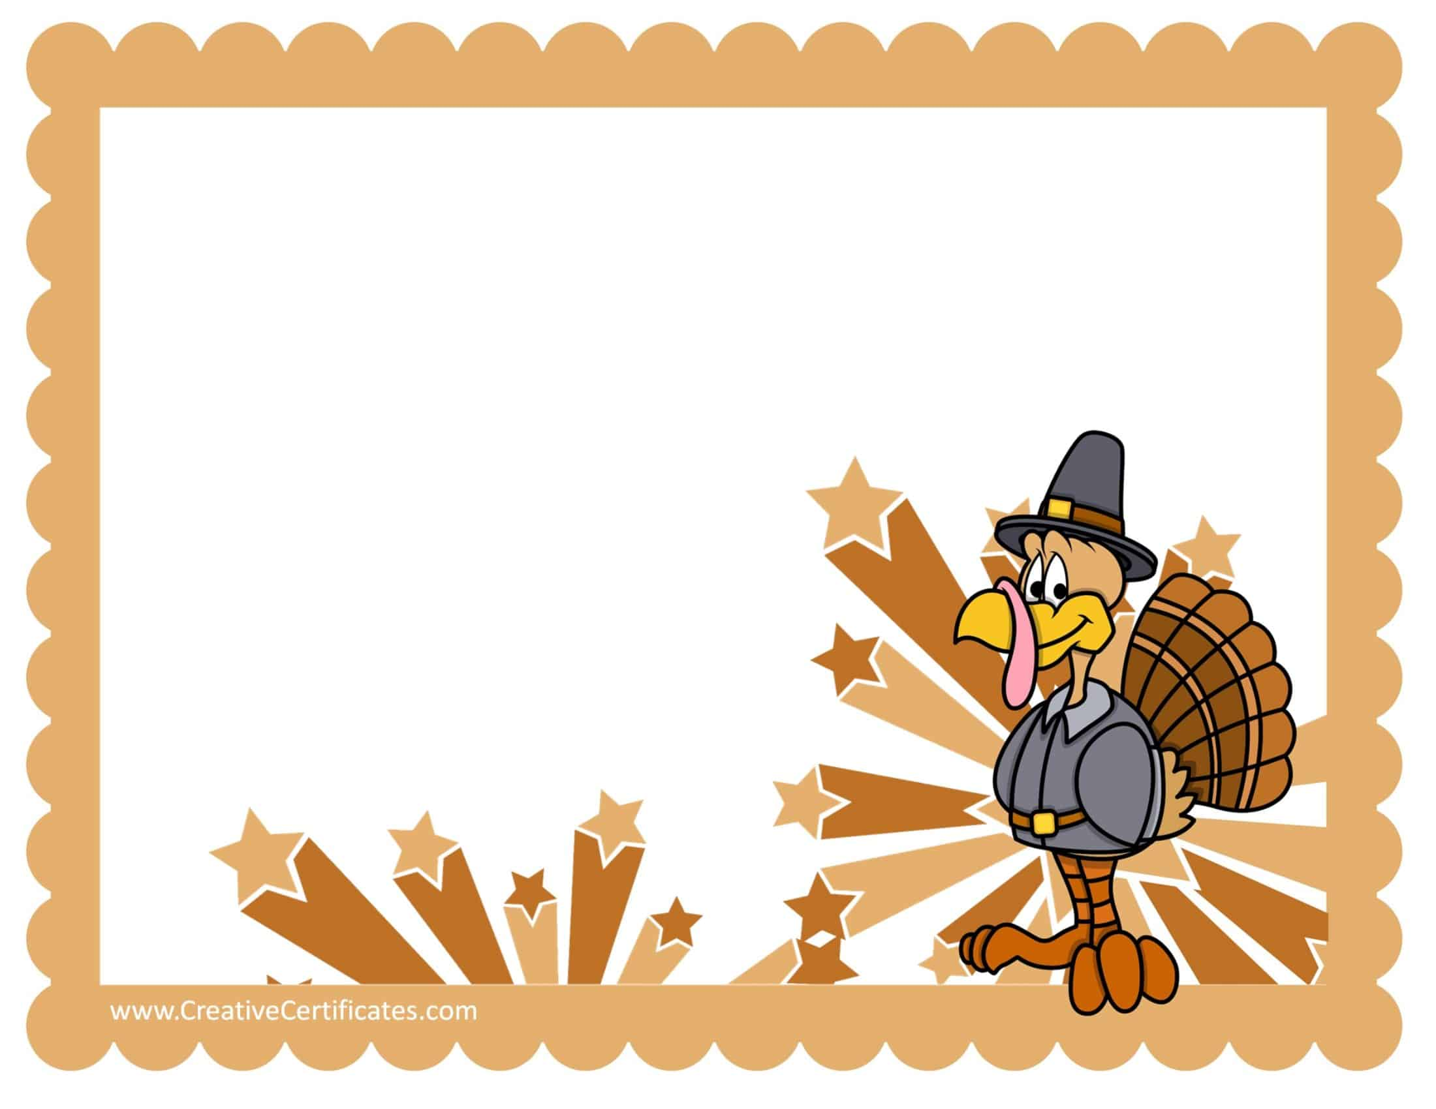
November
This Photo by Unknown Author is licensed under CC BY-SA
This Photo by Unknown Author is licensed under CC BY-SA
Teacher Mrs. Ledya Room #9

