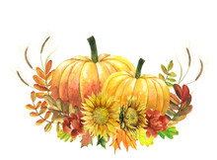Private Kindergarten

Mrs. jenny Room 7

|  |  |  |
| --- | --- | --- |
|  |  |  |
| **Theme** Four Seasons  Outer Space  We Love Pets!  Thanksgiving | OCt. 31st – Nov.4th Alphabet Review  Number Review  **NOV. 7th – 11th**  Letter Rr  Number 7 | **Nov. 14th – 18th**  Letter Cc  Number 8  **Nov. 21st -25th**  Letter Ee  Number 9 |
|  |  |  |

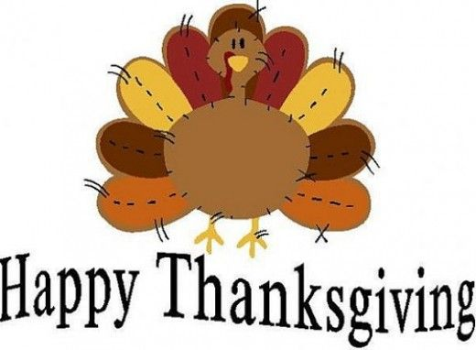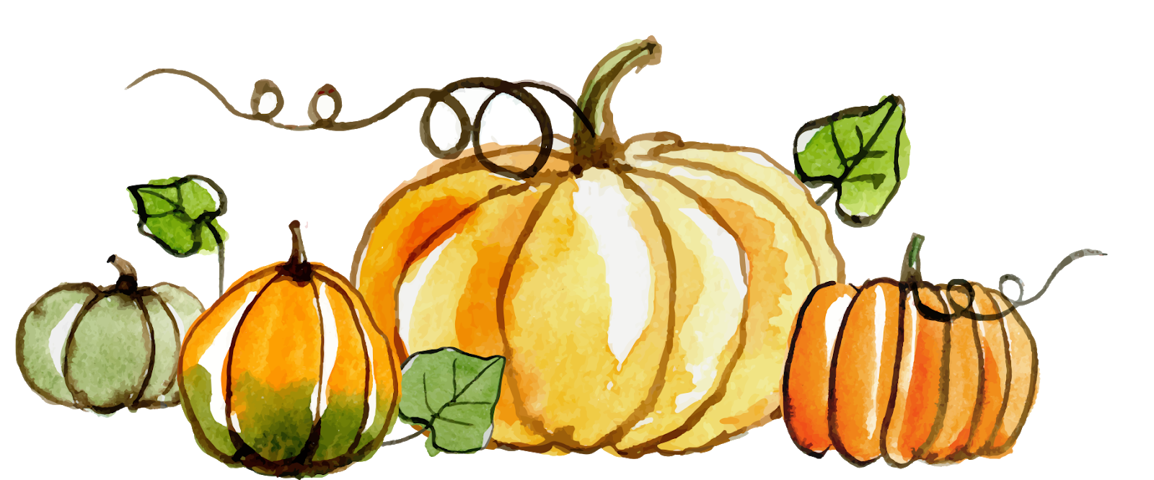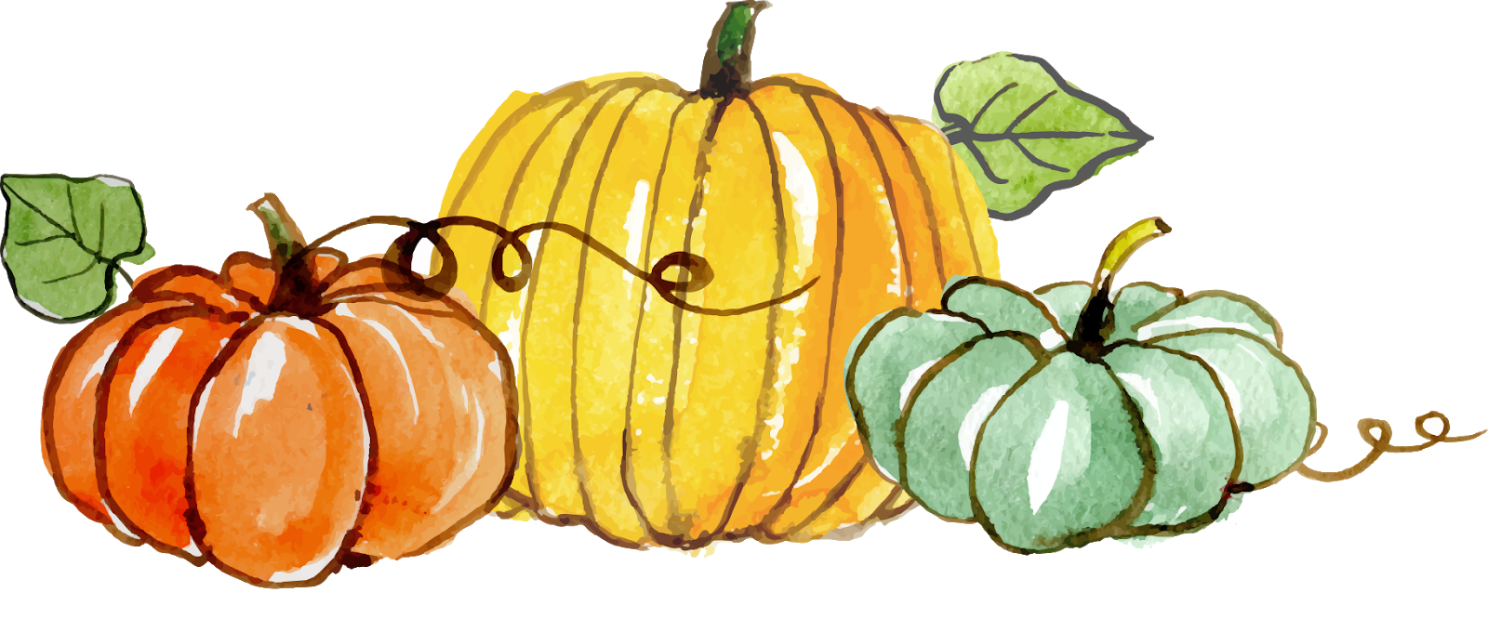

**Save the Date:**

Thanksgiving Feast 11/22

Winter Wonderland & Pictures with Santa Claus

Dec. 14th

**Teacher Notes:**

Mrs. Jenny will be on vacation November 22 and will return Monday the 28th.

**Monthly Quote:**

We know what we are but know not what we may be.

**Up Coming Events:**

Pepper Valley will be closed on November 24th and 25th for Thanksgiving.

Happy Thanksgiving Everyone!

Literature for the Month:

The Frog Prince

Why the Sun and Moon Live in the Sky

Thermometers

How to Catch a Turkey

10 Fat Turkeys

Turkey Goes to School

Harvest Days

###### Nov. 28th – Dec. 2nd

Starting Christmas Crafts