November Newsletter

Room 5 & 6 Mariah and Courtney

**Important Dates**

Thanksgiving party~ 11/22

(The signup sheet for the party is located on bulletin board near sign out sheets)

Closed~ 11/24 and 11/25

**Happy Birthday**

Roy- 11/19

Olivia- 11/22

**This Month We Will Be Learning about**

Fall, Thanksgiving and Kindness!



**Teacher’s Note: Please bring your child no later than 9:15am am so they don’t miss circle time. Ms. Courtney will be off the week of Thanksgiving.**

**Thanks,**

**Ms. Mariah and Ms. Courtney**

**Color Of The Month:** Yellow

**Shape Of The Month:** Circle

**Letters Of The Month:** GHI

**Number Of The Month:** Three

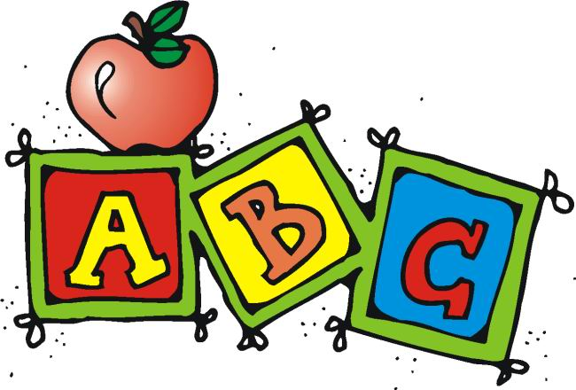

Book Of The Month

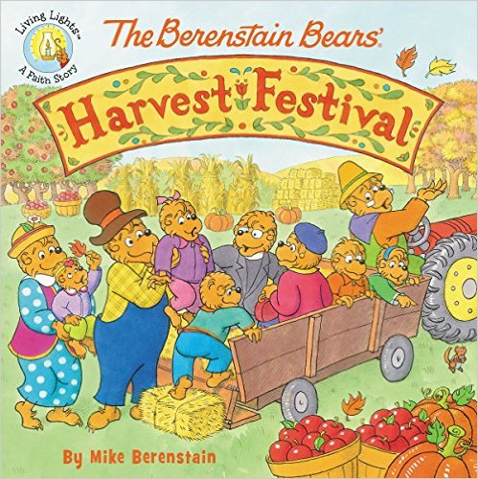

**Reminders**

**Don’t forget to take your child’s nap items home to wash on Friday’s and bring back Monday.**

**Please label jackets with your child’s name.**

**And no toys from home they could get broken or missing.**

**Thanks,**

**Ms. Mariah and Ms. Courtney**